**Background**:

As part of this code challenge you will be using an API available here: <https://swapi.co/>

We want to know for all SW star ships, to cover a given distance, how many stops for resupply are required.

The application will take as input a distance in mega lights (MGLT).

The output should be a collection of all the star ships and the total amount of stops required to make the distance between the planets.

All other application details are at your own discretion.

Sample output for 1000000 input:

Y-wing: 74

Millennium Falcon: 9

Rebel Transport: 11

**NOTE**: The console application can be created in any language you wish to use (not limited to .NET languages).

**Requirements**

1) The completed code should be submitted along with

2) Accompanying documentation

3) Tests and instructions on the usage of the application.

If there are any queries on the challenge I can be contacted for clarification if necessary.

All aspects of the challenge will be considered during the review, coding style, code organization, correct calculations, working application etc.

This is a very important part of the interview process and they like our candidates to put their best code forward.

# Code Documentation

The code has been develop using C# .NET Core 3.1 using Microsoft Visual Studio Community 2019.

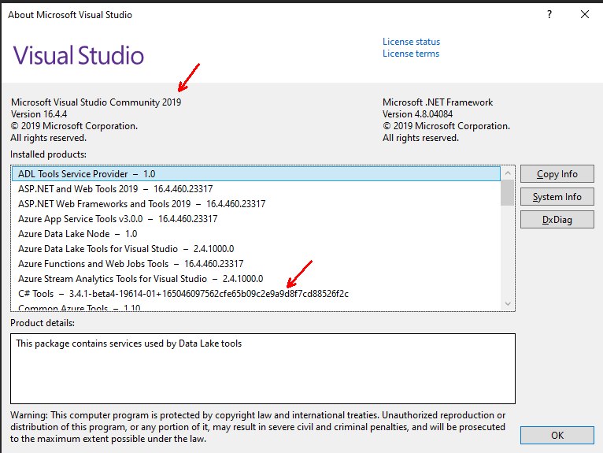

References:

<https://swapi.dev/documentation#csharp>

C# Helper Library (SWapiCSharp by M-Yankov) - <https://github.com/M-Yankov/SWapi-CSharp>

# Instructions

1. Open the code (***SWStarship.sln***) using Visual Studio 2019.

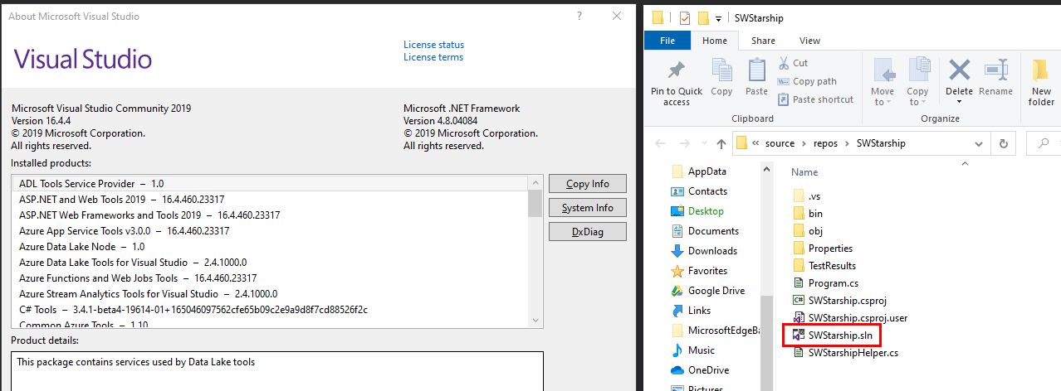

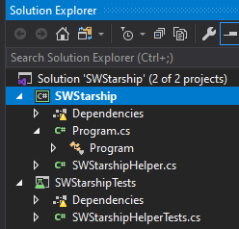

1. Key-in the Mega Lights distance in the space provided and hit the enter key.

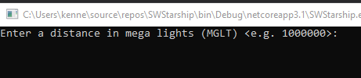

1. Below is the expected results.

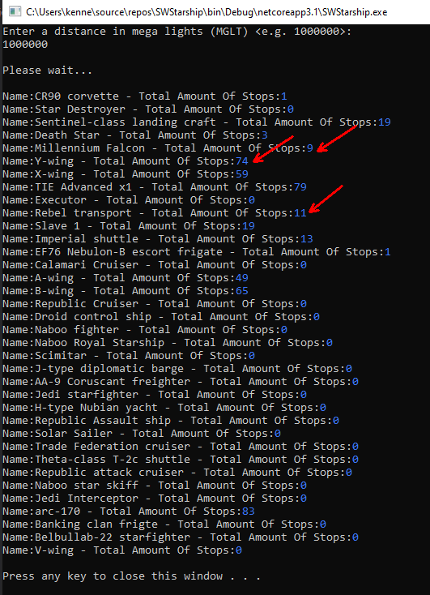

1. Press any key to exit. Thanks!

# Unit Testing

To Unit Test please run All Test under the Test Explorer as shown below.

The ***DataRow*** corresponds the input parameters and expected results.

